Risk Assessment Form – The Quarry - Running
This form should be completed with a list of hazards that affect the session, and should be written from a coaching perspective, not a venue management perspective. For each risk assessment there should be associated Emergency Action plan to be used in case of incident.

Venue: |  | The Quarry, Shrewsbury | Venue Contact Name & Contact Details: | n/a
Address:  (Include postcode) |  | Shrewsbury, SY1 1JA
Group: |  |  | Location of first-aider: | Coach & Reception of Quarry Leisure Centre
Date: |  | 6 July 2023 | Location of Defibrillator | Quarry Leisure Centre, STOP coffee shop, toilets by blue gates
Time: |  | 1800 – 1900 | Location of telephone: | Coach mobile or Leisure Centre Reception
Participants: | Number: | Up to 36 | Location of toilets: | Public toilets in Quarry
 | Age: | 16+ | Location of changing rooms: | Public toilets
 | Ability: | Mixed | Location of first-aid kit: | Leisure Centre Reception
Lead coach name: |  | Coaches will vary | Stocked and maintained: | ☒ Yes ☐ No
Venue documents read and understood  (please ✓ appropriate box): |  | Normal operating procedures:  ☒ Yes ☐ No | Additional notes: | Coaches will have access to contact EC numbers for all participants, including potential new members (to be emailed across by membership officer)
Health and safety policy:
☒ Yes ☐ No
Emergency action plan (EAP):
☒ Yes ☐ No

Name of person conducting risk assessment: | Signed: | Date:
Sorrel Williams | S.Williams | 5 July 2023

Risk Assessment Form – The Quarry - Running

Location & Description of Hazard: | People at Risk: | Level of Risk (High/Medium/ Low): | Advice Required: (from whom) | Action(s) to Mitigate/ Remove Risk: | Person responsible for resolution: | Residual Risk: After resolution | Dates Reviewed
Pre-existing medical condition presenting during session | Athletes, coaches | Likelihood: M  Impact: M | x Yes  If yes, who: Athlete to inform coach of current physical state | - Coaches to screen athletes’ medical declarations.  - Coaches to check for injuries and medical issues before each session commences.  - Membership cards to be handed in prior to start of session.  - Athletes reminded to train within their limits.  - Seek medical assistance if required. | Coaches | Likelihood: L  Impact: M | Annually
Slips, trips & falls | Athletes, coaches | Likelihood: M  Impact: M/H | x No | - Athletes briefed on direction of running  - Advise athletes to take care of wet, icy and slippery surfaces.  - Coaches to pay attention to ground conditions.  - Equipment to be kept tidy and away from path.  - Athletes to be reminded of public space | Coaches | Likelihood: L  Impact: M | Annually
Public, loose dogs, other park users | Athletes, coaches | Likelihood: H  Impact: M/L | Coach | - Remind athletes of other park users  - Keep athletes to one side of the path | Coaches | Likelihood: M  Impact: M/L | Annually
During Summer  Sunburn, dehydration, hyperthermia from weather | Athletes, coaches | Likelihood: M  Impact: M | x Yes  If yes, who: coach | - Encourage athletes to wear suncream during summer.  - Remind athletes to drink during sessions.  - Remind athletes to be dressed appropriately for weather conditions.  - Coaches to monitor athletes for signs of hyperthermia, dehydration, sun stroke, fatigue, stress, injury. | Coaches | Likelihood: L  Impact: M | Annually
During Winter  Hypothermia | Athletes, coaches | Likelihood: M  Impact: M | x Yes  If yes, who: The coach | - Remind athletes to drink during sessions.  - Remind athletes to be dressed appropriately for weather conditions.  - Coaches to monitor athletes for signs of hypothermia, especially in any athletes who have stopped (e.g. due to injury) | Coaches | Likelihood: L  Impact: M | Annually
Fatigue leading to injury | Athletes | Likelihood: L  Impact: M/H | x Yes  If yes, who: Athlete to inform coach of current physical state | - Coaches to monitor athletes for signs of fatigue, stress, injury.  - Coach to rest athletes as required.  - Coach to ask athlete to leave session, if required. | Coaches | Likelihood: L  Impact: M | Annually
Collisions | Athletes, coaches | Likelihood: M  Impact: L/M | x No | - Remind athletes of direction of running  - Ensure athlete numbers evenly distributed across the paths and coach to participant ratios are as per club guidelines.  - Arrive and depart the park together as a group observing other park users. | Coaches | Likelihood: L  Impact: L | Annually

Insert Diagram(s) of layout of venue with key safety elements marked (this page is intended to be shared between Risk Assessment and EAP):

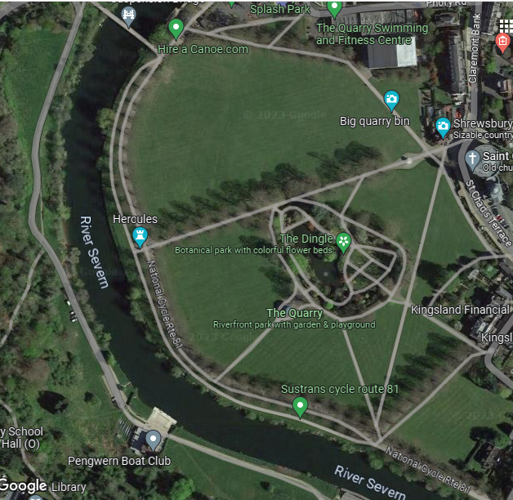
Toilets and defib

meeting point

Reception area:first aid point, assistance/telephone

