Risk Assessment Form
This form should be completed with a list of hazards that affect the session, and should be written from a coaching perspective, not a venue management perspective. For each risk assessment there should be associated Emergency Action plan to be used in case a risk occurs.

Venue: |  | Walford College Lake | Venue Contact Name & Contact Details: | Bronwen Bray  01691 688000
Address:  (Include postcode) |  | Walford Campus, Baschurch, Near Shrewsbury, SY4 2HL
Group: |  | SYTri Lake Swim | Location of first-aider: | Level 2 Coach
Date: |  | Saturday am (May – October only) | Location of Defibrillator | On Site with Coach
Time: |  | 0900-1000 | Location of telephone: | None, mobile reception is good
Participants: | Number: | 30 (max) | Location of toilets: | None
 | Age: | Mixed Adults and Junior club members | Location of changing rooms: | None
 | Ability: | Mixed ability swimmers. All experienced swimmers with varying levels of ability. | Location of first-aid kit: | On lakeside with Coach
Lead coach name: |  | Sorrel Williams | Stocked and maintained: | Yes No
Venue documents read and understood  (please X appropriate box): |  | Normal operating procedures:  Yes No | Additional notes:
 |  | Health and safety policy:  Yes No | Nearest Hospital: Royal Shrewsbury Hospital, Mytton Oak Road, Shrewsbury SY3 8QH Tel No.01743 261691
 |  | Emergency action plan (EAP):  Yes No | Emergency assembly point will be at registration/briefing area.

Name of person conducting risk assessment: | Signed: | Date:
Sorrel Williams | S. Williams | 1 June 2023

Risk Assessment Form

Location & Description of Hazard: | People at Risk: | Level of Risk (High/Medium/Low): | Advice Required: (from whom) | Action(s) to Mitigate/ Remove Risk: | Person responsible for resolution: | Residual Risk: After resolution | Dates Reviewed
Lake; drowning | All swimmers | Likelihood: Medium  Impact: High | No | A level 2 or above coach will be present at every session.  - No entry until sanctioned by coach  - Bright coloured hats mandatory  - Tow floats recommended  - Body marked  - Swimmers to swim with buddy where possible  - Swimmers checked into and out of water  - Min 2 spotters around edge to assist coach in observation  - Swimmers reasonably confident swimmers  - Numbers restricted to 30  - Coach and spotters (not assistant who is checking in and out) to stand on edge side and observe swimmers  - Access to 3 x safety rings for coach and spotters  - Kayak/on water observer  - Contact between spotters and coach via whistle  - -preswim briefing mandatory on entry, exit, swim routes and calling for help | Coach | Likelihood: Low  Impact: High | 1 June 2023
Lake and surrounds; physical injuries through hitting other swimmers, lake sides/ground etc | All persons on site. | Likelihood: Medium  Impact: Medium | No | Sessions held with coloured buoys, with swimmers advised in briefing as to course route so swimmers are going in the same direction.  Diving not permitted. The area around the lake is grassed and in some areas rutted by farm vehicles. around the lake, a parking area will be indicated to persons arriving to avoid the ruts, there is also a layby by the site entrance. A path to the lake shore will also be indicated to swimmers. | Coach | Likelihood: Low  Impact: Medium | 1 June 2023
Lake; physiological conditions, e.g., hypothermia, cramp, dehydration, tiredness, exhaustion. | All swimmers | Likelihood: Medium  Impact: Low | No | Coach will measure the water temperature before every session and be guided by the BT race rules for minimum and maximum water temperatures and shorten or cancel the swim session if appropriate. For the temperatures below the swim lengths will be adjusted  accordingly: -  11C = 500M,  12C = 1,000M  13C = 2,000M  The effect of wind chill at other temperatures should be noted. Wet suits required to be worn by all swimmers; at temperatures above 24C it is advisable for swimmers not to wear wetsuits. Acclimatizing to the water will be part of the coached session. Swimmers told not to push the amount of time spent in cold water. Space blankets will be available. Swimmers encouraged to bring lots of spare warm clothes. Coach to give additional consideration to temperatures in relation to junior swimmers and where necessary limit their time in the water. | Coach | Likelihood: Low  Impact: Low | 1 June 2023
Lake entry / egress area; slips and trips | All participants | Likelihood: Medium  Impact: Medium | No | Ensure areas around the lake entry and egress are kept clear of bags & equipment. Participants reminded banks can be muddy and slippery – care should be taken getting in and out of the lake. The entry into the water is by a natural slope. | Coach | Likelihood: Low  Impact: Medium | 1 June 2023
Lake; swimmers medical issues (e.g. asthma, diabetes, anaphylaxis) | All swimmers | Likelihood: Medium  Impact: Medium | No - | Before entering the water, all swimmers will have:  Acknowledge that they have read a pre-swim on-line disclaimer as part of pre booking the session. This includes that they will be required to provide at the session their name, address, an emergency contact telephone number and information about any medical condition.  Those with a medical condition will be required to inform the coach of the condition and the type and whereabouts of any medication.  Club members have been informed that individual members remain responsible for self-administering any medication. | Coach | Likelihood: Low  Impact: Medium | 1 June 2023
Lake; injury / drowning caused by aggressive swans | All swimmers and Kayakers | Likelihood: Low Impact: High | No | Coach and kayaker to inspect lake before each session and look out for any swans, particularly those guarding nests or young. If present consider cancelling session unless it is clear that the swan(s) and swimmers can occupy opposite ends of the lake without conflict. Kayakers to take special care and anticipate potential aggressive attack, which may result in over-tipping or serious impact injury. | Coach / Kayaker | Likelihood: Low  Impact: Medium | 1 June 2023
Lake: Weather (heavy rain, fog, lightning) | All participants | Likelihood: Medium  Impact: High | No | Coach to check weather forecast before each session, and monitor actual conditions before and during session, cancelling and ending the session if the weather conditions dictate (e.g. low visibility, high risk of lighting) | Coach | Likelihood: Low  Impact: High | 1 June 2023
Lake: Water quality | All swimmers and Kayaker | Likelihood: Medium  Impact: Medium | No | Coach to receive water quality test checks from venue owner and observe for any signs of pollution or build-up of algae (especially Blue-Green in May-August), and seek appropriate testing if in doubt. | Coach | Likelihood: Low  Impact: Medium | 1 June 2023
Add more pages as required

Insert Diagram(s) of layout of venue with key safety elements marked (this page is intended to be shared between Risk Assessment and EAP):
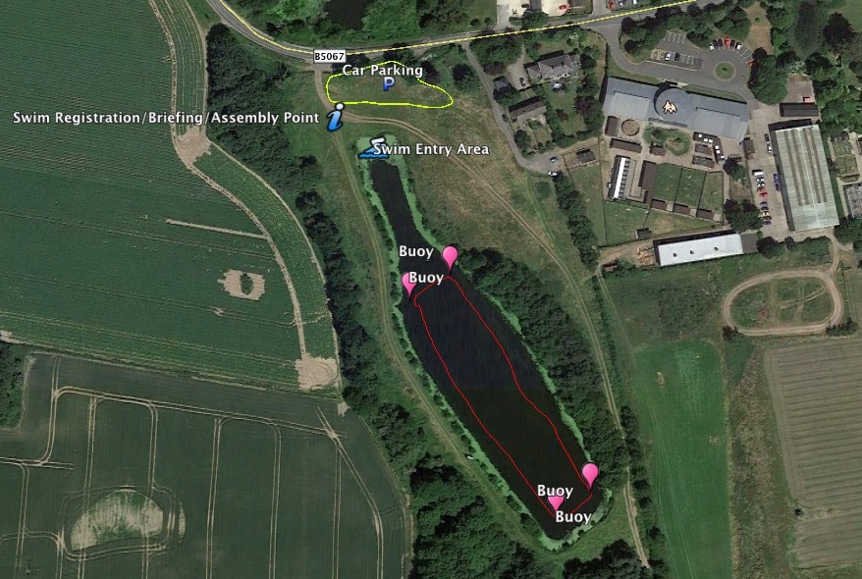
General Location of Head coach during swim

