Emergency Action Plan
This document can be used for sessions held at managed venues or venues where there are no staff. Where the coach is ultimately responsible for health and safety there is greater onus on them to ensure that safety provision is adequate. EAP should be read in conjunction with the Risk Assessment.

Venue: |  | The Quarry
EAP created by: |  | Sorrel Williams |  | Date Created: | 4 July 2023
Venue Address:  (Inc. Postcode/ Grid Reference) |  | The Quarry, Shrewsbury, SY1 1JA
Type(s) of Activity this EAP applies to: |  | Club Running Sessions
Who is ultimately responsible for Health & Safety during these sessions: |  | Venue Staff  Coaching Staff  Other  Comments: | Unmanaged venue but First Aid available from Fitness and Leisure Centre
How will venue staff be contacted in emergency: |  | N/A
Location of Phone/Mobile Reception Tested: |  | Mobile phone reception good. Reception phone approx. 2-400m.
Location of the nearest first-aid qualified person: |  | Coach and Quarry Leisure Centre Reception
Location of first-aid equipment: |  | Coach and Quarry Leisure Centre Reception
Location of Defibrillator: |  | Coach and Quarry Leisure Centre Reception, Stop café, toilets at blue gates
Non-Managed Venues
How to contact Emergency Services: |  | Coach mobile, Quarry Leisure Centre Reception
How will Emergency Services be directed to the scene of an incident: |  | Athletes/participants to stand at Quarry Entrance on St Chads
Who else is available to help in case of issues: |  | Quarry Leisure Centre staff
Managed Venues:
List the Actions that the COACH can undertake to ASSIST venue staff:
Non-Managed Venues:
List ALL the Actions that the COACH will undertake and Manage others to do if any of the following situations occurs:
Evacuation: | FOLLOW INSTRUCTIONS OF EMERGENCY SERVICES, IN THEIR ABSENCE  ▪ If anyone suspects fire/gas leak/structural failure or other reason to evacuate alert all athletes and coaches by shouting -COACHES EMERGENCY, call emergency services  ▪ Coaches to ensure all athletes and coaches evacuate the site and congregate in the main car park next to St Chads church, or if exit is blocked due to reason for evacuation, cross Porthill bridge and congregate on road  ▪ Check all athletes accounted for against the sign in register.  ▪ If anyone missing notify any emergency services present.  ▪ Do not re-enter
Minor Injury: | ▪ Upon discovery of a casualty with minor injuries let the other coaches know and consider whether the athlete needs treatment and if the treatment will impact on management of coached group. If appropriate, consider handing responsibility of group to another coach temporarily while casualty is dealt with.  ▪ First aid should only be given by a qualified First Aider.  ▪ The first aider for the session will normally be the coach  ▪ Coaches should remember to consider the safety of other participants and stop / suspend the session if they are distracted by dealing with the casualty  ▪ The First Aider should treat the casualty in line with the guidance of their qualification  ▪ When treating a casualty don’t leave yourself in a compromising position. E.g. male first aider alone with a female casualty or adult with a child/junior.  ▪ The Club Head coach should be informed of any minor injuries so that relevant documentation can be completed.  ▪ Coaches should follow the CLUB accident reporting online procedure including noting the incident.
Major Injury: | SUPPORT EMERGENCY SERVICES – likely actions required:  (All cases of head injury should be treated as serious.)  ▪ Make all coaches aware by shouting “Coaches - Emergency”  ▪ All coaches stop session immediately.  ▪ Coach (A) or athlete nearest the defib locations should go and get Defibrillator immediately (code from calling 999) and bring back to casualty. They should notify emergency services on 999 and tell them there is an incident.  ▪ Remaining coaches should (A) attend to the casualty in line with their first aid qualification, other available coaches or lead participant to take control of all other athletes at the park and move them away from the athlete and ensure emergency services have been called if not already.  ▪ For adult sessions it may be possible to delegate responsibility of managing the group to a committee or senior member or the club, so they can assist other coaches. It may be possible that there are medically trained individuals at the session who can provide assistance, ask if there are, but don’t rely upon it.  ▪ Await arrival of emergency services, continuing to treat casualty, assist them and hand over when they have taken responsibility.  Provide Emergency services details of any medication, known medical history and in case or emergencies contact details, these are available from sign in sheet, membership card and access to membership database.

Insert Diagram(s) of layout of venue with key safety elements marked (this page is intended to be shared between Risk Assessment and EAP):

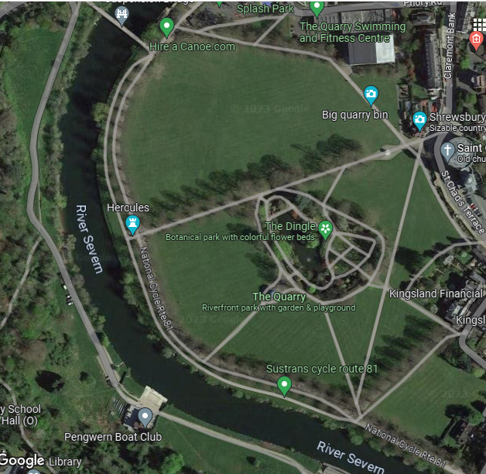

Reception area:first aid point, assistance/telephone

Toilets and defib

Emergency entrance

